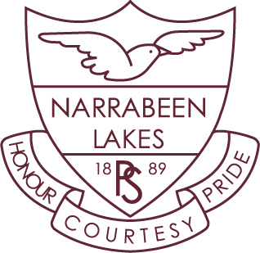

**Stage Two – Term 3**

Dear Parents and Carers,

Welcome back to Term 3. We hope you had a relaxing Winter break and your children enjoyed the holidays. I know that we certainly did! With Healthy Harold, PCS Music Festival, Open Day, Book Week and of course

N-Factor, Term 3 is shaping up to be a very busy term.

Below are a few important dates for your diary.

**Dates for Term 3**

**Week 1 & 2** Fight on the Beaches Xmas in July Mufti Day-Thursday 25th July

Life Education (Healthy Harold)

**Week 2** Arts Alive Drama Festival for 4P- Thursday 1st August

Sports and Band Photos- Friday 2nd August

**Week 3** PCS Music Festival

**Week 5** Open Day and Book Week including the Book Parade- Tuesday 20th August

**Week 9** N-Factor- Thursday 19th September

**Personal Developmental/Health**

Students are looking forward to a visit from Healthy Harold and the Life Education van this term. We will be also teaching about Drug Education looking at the use and safe storage of medicines and how they affect the body. We will also be continuing our Second Step program which focusses on developing and maintaining positive peer relationships. Sport is on a Friday so students must wear our full sports uniform to school. Students selected to participate in PSSA sport at various venues must remember to bring their protective equipment (hat, shin pads, mouthgards etc).

**HSIE – History**

This term Stage Two will be studying the unit ‘Community and Remembrance’ which focusses on various celebrations throughout Australia and the world.

**Science**

The topic will be ‘States of Matter’ and the unit will focus on how solids and liquids change state and the properties of natural and processed materials.

**Homework**

Homework will begin on Friday, Week 1. It will be due on Friday of odd weeks. House points will continue to be given to students who return their signed homework grid each fortnight.

Kind regards,

Mr Phillips, Mrs Mule, Ms Nelson, Mrs Clark and Mrs Donohoe