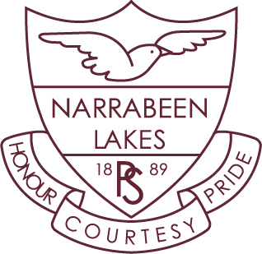

**Stage Two – Term 4**

Dear Parents and Carers,

Welcome back to Term 4. We hope you all enjoyed the holidays. It’s hard to believe we are in the last term of the school year. It looks like it’s going to be another busy term.

Below are a few important dates for your diary.

**Dates for Term 4**

**Week 1** Summer PSSA commences

**Week 2** Stage 2 Operation Art Workshops- Monday 21st October

NSW State Drama Festival for 4P- Tuesday 22nd rehearsal,

Thursday 24th matinee performance

**Week 6** School Spectacular- Friday 22nd, Saturday 23rd November

**Week 7** Environment Day- Wednesday 27th November

**Week 9** Parent Helper lunch- Tuesday 10th December

Presentation Day- Thursday 12th December

**Week 10** End of Year Excursion- Wednesday 18th December

**Personal Developmental/Health**

We will be teaching about Child Protection which focusses on strategies that students can use to keep themselves safe. We will also be continuing our Second Step program which focusses on developing and maintaining positive peer relationships. Sport is on a Friday so students must wear our full sports uniform to school. Students selected to participate in PSSA sport at various venues must remember to bring their protective equipment (hat, shin pads, mouth guards, etc).

**Science**

The topic will be ‘Earth and its Surroundings’ and the unit will focus on how natural and man-made disasters affect the Earth’s surface.

**Homework**

Homework will begin on Friday, Week 1. It will be due on Friday of odd weeks. House points will continue to be given to students who return their signed homework grid each fortnight.

Kind regards,

Mr Phillips, Mrs Mule, Ms Nelson, Mrs Clark and Mrs Donohoe